Darrell Percey && Andrew Boven

Project 3 || System Networks II

Protocol Documentation

**Packet:**

struct packet{

char orgSender;

char currSender;

int hops;

char label[SIZE];

int distance[SIZE];

} packet;

This is the basic structure of the packets sent and received on the network. This will allow for the sender to put its label as the original sender char. The current sender char is available for the person forwarding the packet so the receiver knows who the original sender is and the current sender is. The hops are the amount of times the packet can be passed on before it should be dropped by one of the routers. The array of labels and distances are the routers labels and distance from the current sender.

**Receiving Packet && Forwarding Packet:**

On receiving a packet the router must generate a new packet to forward to its neighbors. If the router finds its own label within the packet as a label it will set its distance to 0 before forwarding the packet. The next router handles this just fine and won’t change a value to 0 unless it’s itself. If a label is received and it’s a neighbor node it will check if the distance shown is 0. If so then it knows the sender of the packet was the neighbor and can set the distance to the amount of the neighbor’s distance. If however the label is a neighbor and the distance isn’t zero that means that there is a path through another router to this neighbor. If the path is shorter then even though the router is a neighbor it will set the table for the quicker path through the other router. Lastly if the label is not itself or a neighbor it will test if the router is known. If the router is known it will try to update the distance to the new distance if it is shorter otherwise it will ignore it the distance. These steps are repeated till the router has received at least one packet from each of the other routers on the network so that it can tell if the information is full gained from each router. This will insure that the paths to each router from each router is the shortest and best path. Below in Figure 1 and 2 it shows a basic test run for the program.

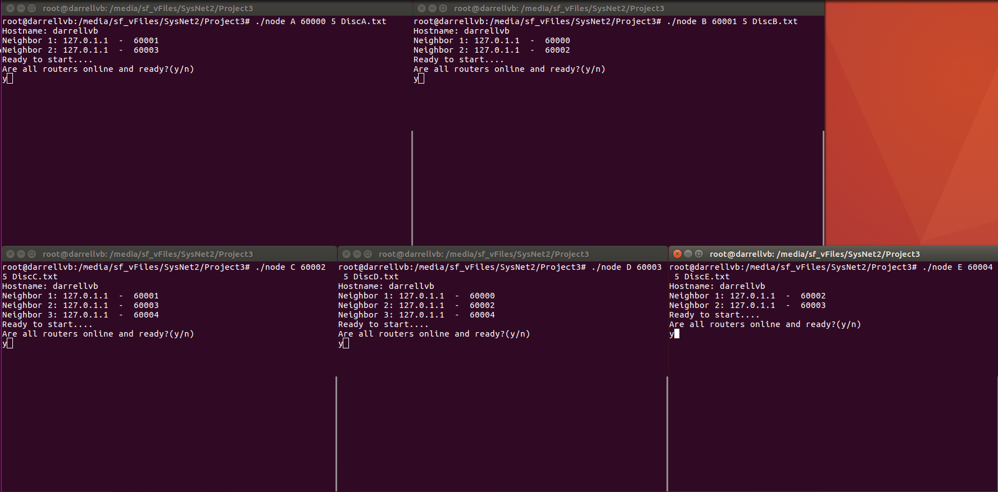

Figure 1: Starting up each of the routers

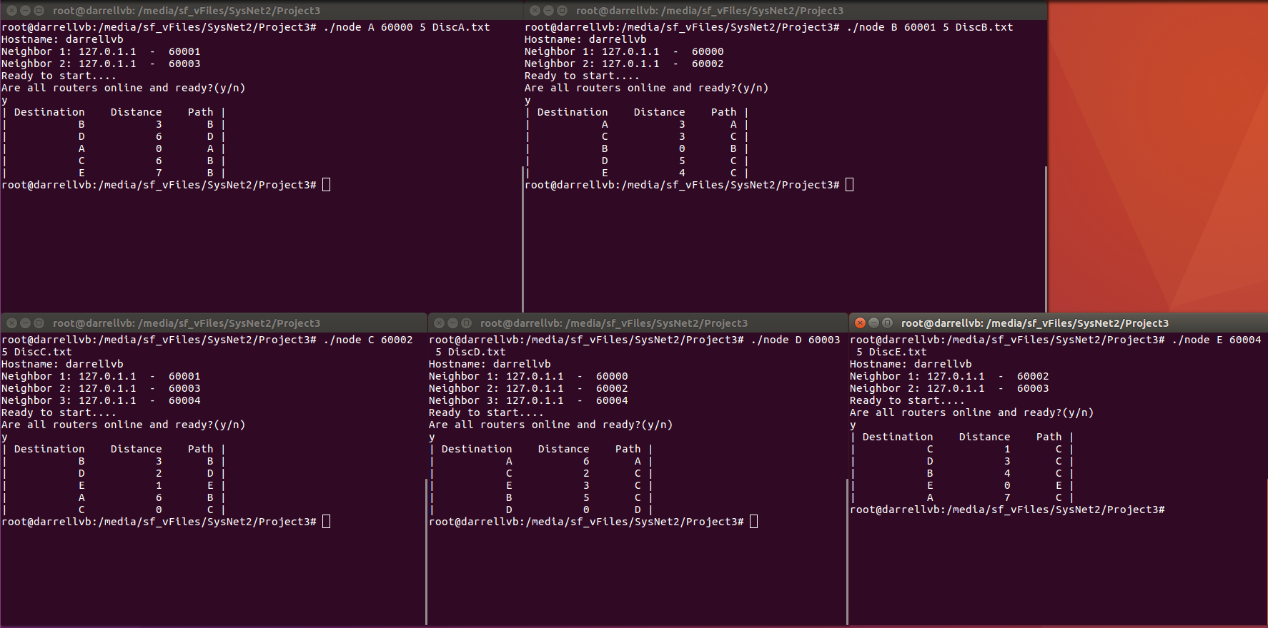You must enter in the label of the router, port of the router, the total number of routers in the network, and the discovery text file to start up the program. You must ensure that the text file is properly written and all information is entered correctly. Once all programs are launched it will tell you it is ready and you must enter ‘y’ to each it will then give you 6seconds to enter ‘y’ to each this will synchronize them better. Figure 2 below shows the final results.

Figure 2: Final results after running